**ITSE 1330 – Intro to C#**

**Module 4 - Project 4**

**There are 4 projects for this Module. Place both project folders in a folder called FirstnameLastnameCSMod4. When you are done with all 4 projects, zip the folder and submit via Moodle. DO NOT ZIP EACH INDIVIDUAL PROJECT, only the outer folder.**

*Create a Windows Forms application named* ***FirstNameLastName4A***

*Save the application in the FirstnameLastnameCSMod4 folder.*

If you know a vehicle’s speed and the amount of time it has traveled, you can calculate the distance it has travelled as follows: Distance=Speed *Time

For example, if a train travels 40 miles per hour for 3 hours, the distance traveled is 120 miles.

Create an application with a form similar to the one below. The user enters a vehicle’s speed and the number of hours traveled into text boxes. When the user clicks the Calculate button, the application should use a **for** loop to display in a list box the distance the vehicle has traveled for each hour of that time period.

Example Form:

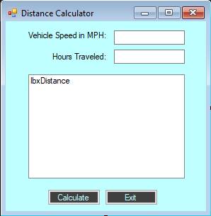

*Create a Windows Forms application named* ***FirstNameLastName4B***

*Save the application in the FirstnameLastnameCSMod4 folder.*

Create an application that predicts the approximate size of a population of organisms. The application should use text boxes to allow the user to enter the starting number of organisms, the average daily population increase (as a percentage), and the number of days the organisms will be left to multiply. Include the heading **1 time** as the first line at the top of the listbox. Use a **while** loop for this project.

For example, assume the user enters the following values:

Starting number of organisms: 2

Average daily increase: 30%

Number of days to multiply: 10

Should generate the following in the listbox control.

Day Approximate Population

1. 2
2. 2.6
3. 3.38
4. 4.394
5. 5.7122
6. 7.42586
7. 9.623619
8. 12.5497
9. 16.31462
10. 21.209

Example Form:

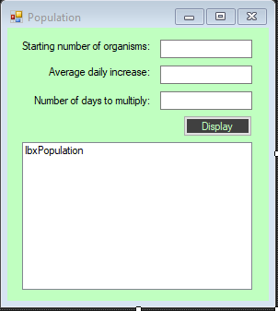

*Create a Windows Forms application named* ***FirstNameLastName4C***

*Save the application in the FirstnameLastnameCSMod4 folder.*

Create an application that contains an instruction label, a name label, a name textbox and write button. When the writes button is clicked you should write the name entered in the textbox to a file named name.txt. Each time a name is entered it should add that name to the file on a new line. If there is no text in the textbox have a message box that states a name must be entered. Do not write an empty line to the text file. When done close the file. Add a working exit button.

Example Form:

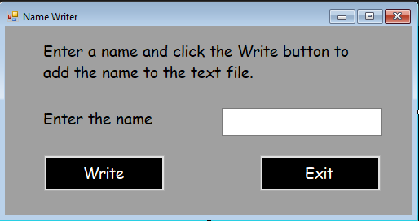

*Create a Windows Forms application named* ***FirstNameLastName4D***

*Save the application in the FirstnameLastnameCSMod4 folder.*

Create an application that when it loads it lists the names on separate lines from the name.txt file. You will have to place a copy of the file in your debug/bin folder of your project after you do Project 4C.

Example Form:

